**DR. VIRENDRA SWARUP INSTITUTE OF COMPUTER STUDIES**

**BACHELOR OF COMPUTER APPLICATION**

**BATCH(2024-2027)**

**↪Project: 3**

Integrate Grafana with Linux Server for high cpu utilization and create a graph in Grafana.

**In this project, we will learn how the most critical metrics to track is CPU utilization, as high usage can lead to system slowdowns, crashes, or service unavailability. In this project, we demonstrate how to integrate Grafana with a Linux server to monitor CPU usage effectively. By leveraging loki for metric collection, promtail to collect, label, and ship logs from various sources to a central Loki instance for storage and querying for data aggregation, and Grafana for visualization, we create an interactive dashboard that provides live insights into CPU performance**.

**Table of Contents**

**↪Project Overview**

**↪Objective**

**↪Technologies used**

**↪ System Architecture**

**↪** **Installation and Configuration**

**↪ Connecting Grafana with Loki**

**↪** **Log Collection with Promtail**

**↪** **Testing and Validation**

**↪** **Results and Observations**

**↪** **Conclusion**

1. **Project Overview**

In this project, we implement a centralized **log monitoring and visualization system** using **Grafana**, **Loki**, and **Promtail**. Modern infrastructure generates vast amounts of logs from services, applications, and system processes. Analyzing these logs in real time is essential for debugging, auditing, and maintaining the overall health of systems.

To address this need, we use **Loki**—a log aggregation system developed by Grafana Labs—designed to work efficiently with **Grafana** dashboards. **Promtail** acts as a lightweight log collector that ships logs from Linux servers to Loki. These logs can then be queried, filtered, and visualized within **Grafana**

**↪ Project flowchart**

**[Linux Server / EC2 Instance]**

**│**

**▼**

**[Promtail (Log Collector)]**

**│**

**▼**

**[Loki (Log Aggregation and Storage)]**

**│**

**▼**

**[Grafana (Log Visualization & Dashboard)]**

**2. Objective**

The objective of this project is to design and implement a **real-time log monitoring and visualization system** using **Grafana**, **Loki**, and **Promtail** on a Linux server environment. This system aims to **centralize log collection**, **streamline analysis**, and **enhance observability** across applications and infrastructure by:

* Collecting system and application logs from Linux servers using **Promtail**.
* Aggregating and indexing logs with **Loki** for efficient storage and retrieval.
* Visualizing and querying logs through **Grafana dashboards** using **LogQL**.
* Providing a user-friendly interface to search, filter, and monitor logs in real time.
* Enabling faster **troubleshooting**, **error tracking**, and **audit logging** without using heavy log indexing solutions like ELK (Elasticsearch, Logstash, Kibana).

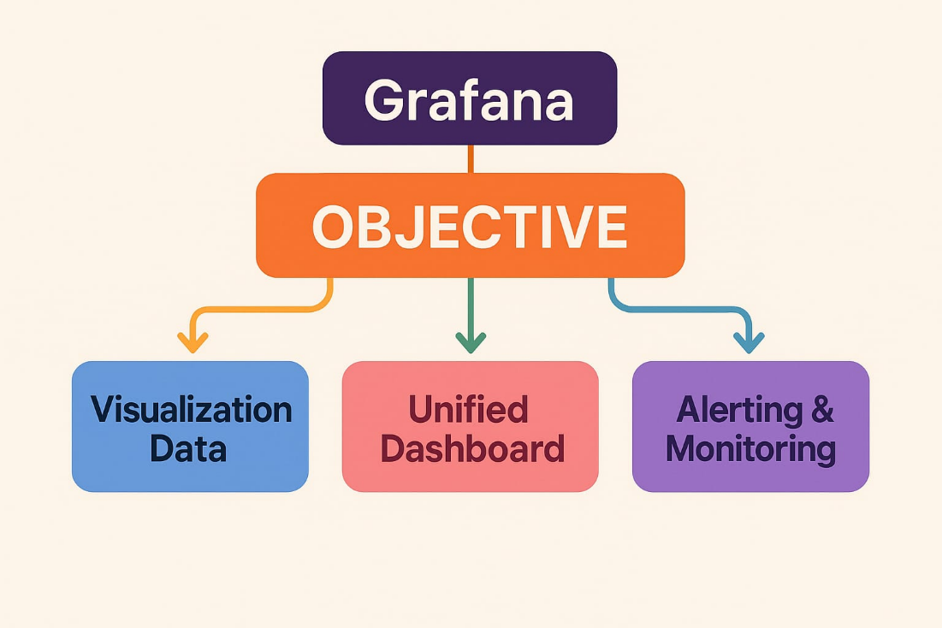

3. **Technologies used**

This project utilizes a modern, open-source observability stack built around **Grafana**, **Loki**, and **Promtail** to enable real-time log monitoring on Linux servers. Grafana serves as the primary visualization tool, allowing users to build dashboards, query log data, and analyze system behavior through a user-friendly interface. It connects directly to Loki, a lightweight and highly scalable log aggregation system developed by Grafana Labs. Unlike traditional log management tools, Loki indexes logs based on labels rather than content, making it much more efficient and cost-effective.

To feed logs into Loki, we use **Promtail**, a log collection agent that runs on Linux servers. **Promtai**l reads logs from system files (such as /var/log/syslog or journalctl), attaches metadata like job name or instance labels, and pushes them to Loki. Logs are then queried using **LogQL**, a specialized query language similar to **PromQL**, designed specifically for filtering and analyzing logs stored in Loki.

The entire stack runs on a **Linux server**—typically a physical machine or a virtual instance such as **AWS EC2**—which serves as the source of log data. **YAML** configuration files are used to define how **Promtail** and Loki operate, making the setup flexible and easy to manage. Optionally, tools like **Docker** can be used to containerize and deploy the entire stack, simplifying installation and scalability.

**↪In short, Technologies used**

* **Linux Server / EC2**
* **Promtail**
* **Loki**
* **Grafana**
* **LogQL**

**4. System Architecture**

The architecture of the log monitoring system is based on a modular, scalable stack consisting of **Promtail**, **Loki**, and **Grafana**, all working together to collect, store, and visualize logs from one or more Linux servers.

### **Component Roles**

* **Linux Server / EC2**: The log source — generates system or application logs.
* **Promtail**: Installed on each server to **collect logs** from files like /var/log/syslog, add **labels**, and **push** them to Loki.
* **Loki**: Acts as the **central log aggregator**. It stores the logs in a time-series format, indexed by labels, not log content — making it efficient.
* **Grafana**: Connects to Loki as a data source. It lets users **query logs using LogQL**, **create dashboards**, and set up visual or alert-based monitoring.
* **LogQL**: A query language specific to Loki, similar to PromQL, used in Grafana to **filter, search, and analyze logs**.

**5. Installation and Configuration**

**🧩 Step-by-Step Deployment:**

**Logged in to AWS Management Console**.

**Task 1: Launch an Instances**

* **Click the “Launch Instances” button.**
* **Fill out the following:**
* **Name and Tags**
* **Give your instance a name (My first Instance).**

**2. Application and OS Images (AMI)**

* **Choose an AMI (Amazon Machine Image):**

* **Example: ubuntu, windows etc.**

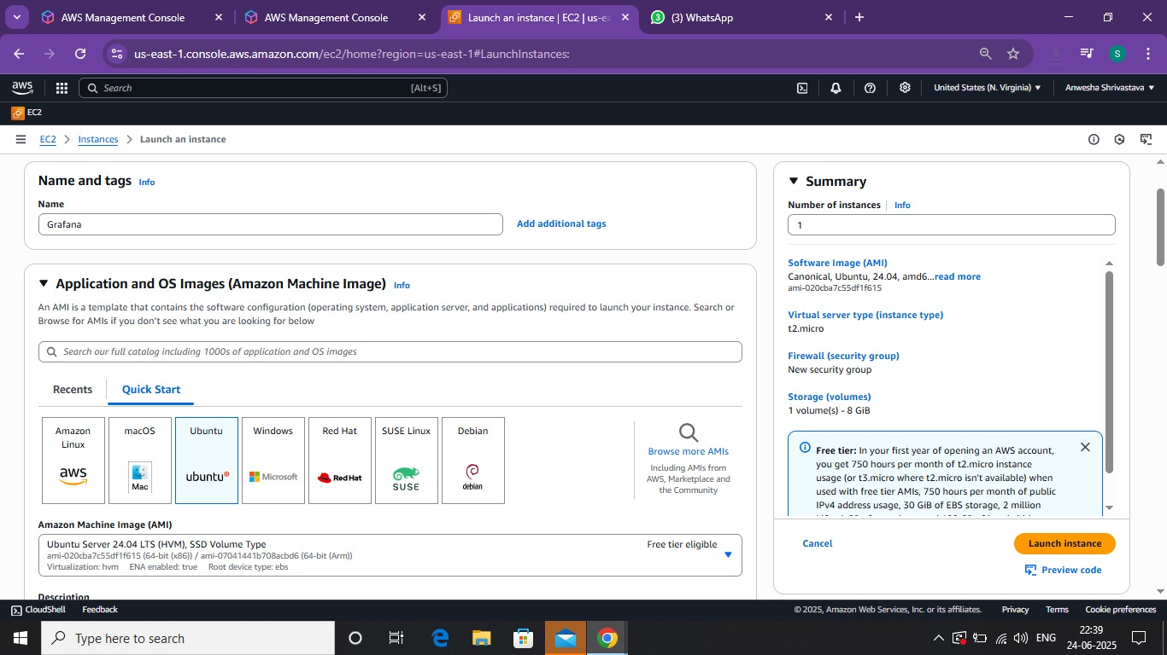

3.Instance Type

* Choose an Instances type (default is t2. micro- Free Tier eligible).

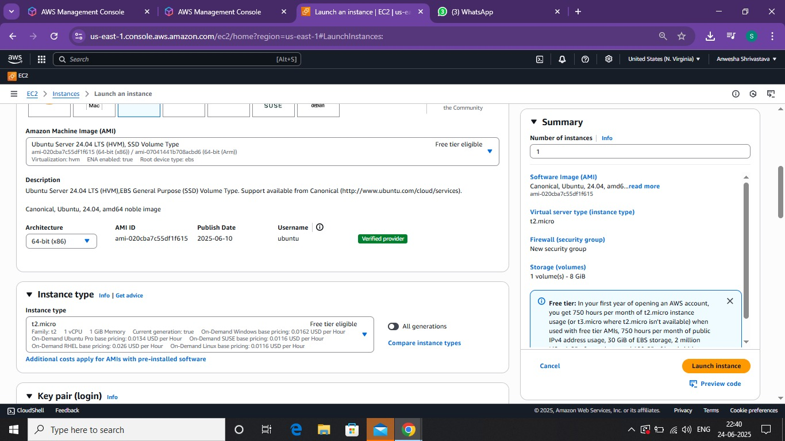

4. Key Pair (login)

* Create a new key pair (if you don't have one)
* Download the. pem file- this is needed for SSH access.

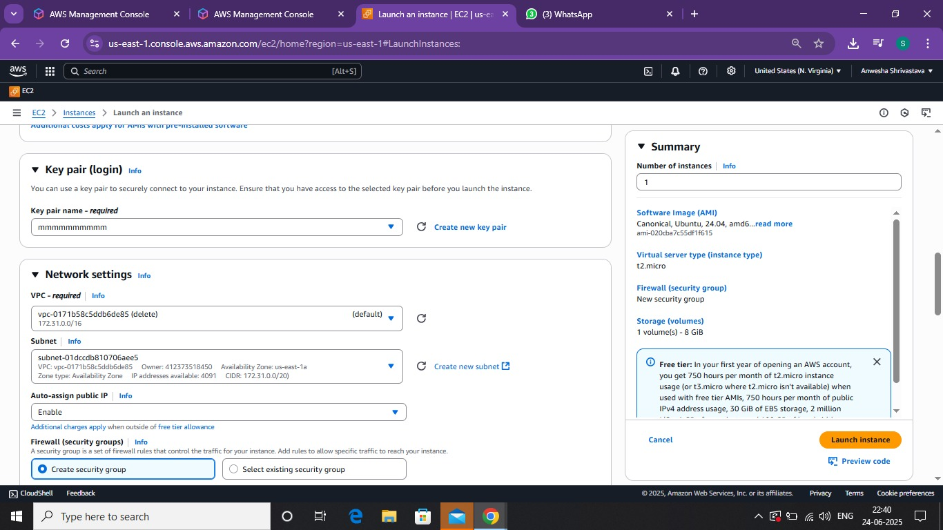

4: Launch the Instance

* Click “Launch Instances”.

5: Connect to the Instances

For Linux:

* Go to the Instances-> Select your Instances-> Connect.
* Now copy the SSH Client address

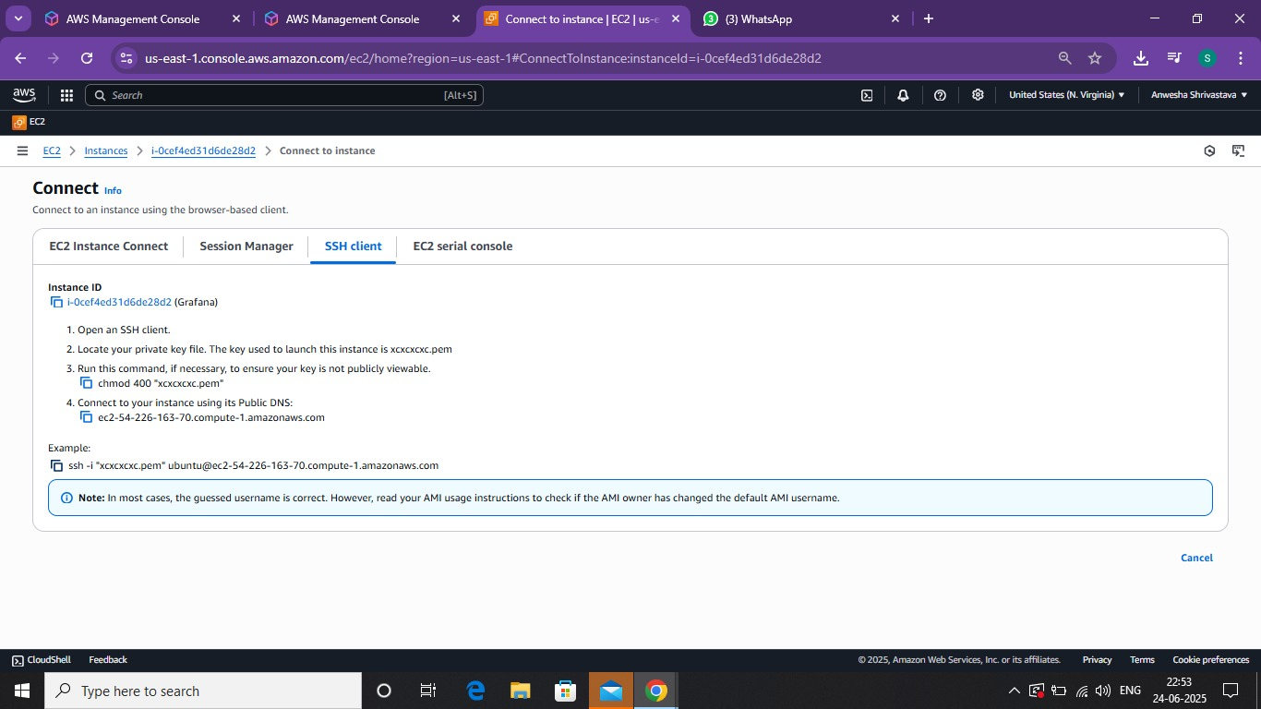

**Some Commands to install grafana:**

* Sudo and paste the ssh client address.
* Sudo apt-get update.
* Sudo apt update.

Sudo apt upgrade –y.

* Sudo apt install -y apt-transport-https software-properties-common wget.
* wget -q -O - https://apt.grafana.com/gpg.key | gpg --dearmor | Sudo tee /usr/share/keyrings/grafana.gpg > /dev/null.
* echo "deb [signed-by=/usr/share/keyrings/grafana.gpg] https://apt.grafana.com stable main" | Sudo tee -a /etc/apt/sources.list.d/Grafana. List.
* Sudo apt update.
* Sudo apt install Grafana.
* Sudo systemctl start Grafana-server.

Sudo systemic enable Grafana-server.

* Sudo systemic status Grafana-server.
* Grafana-server –v.

6.create a security group:

* Go to security group.

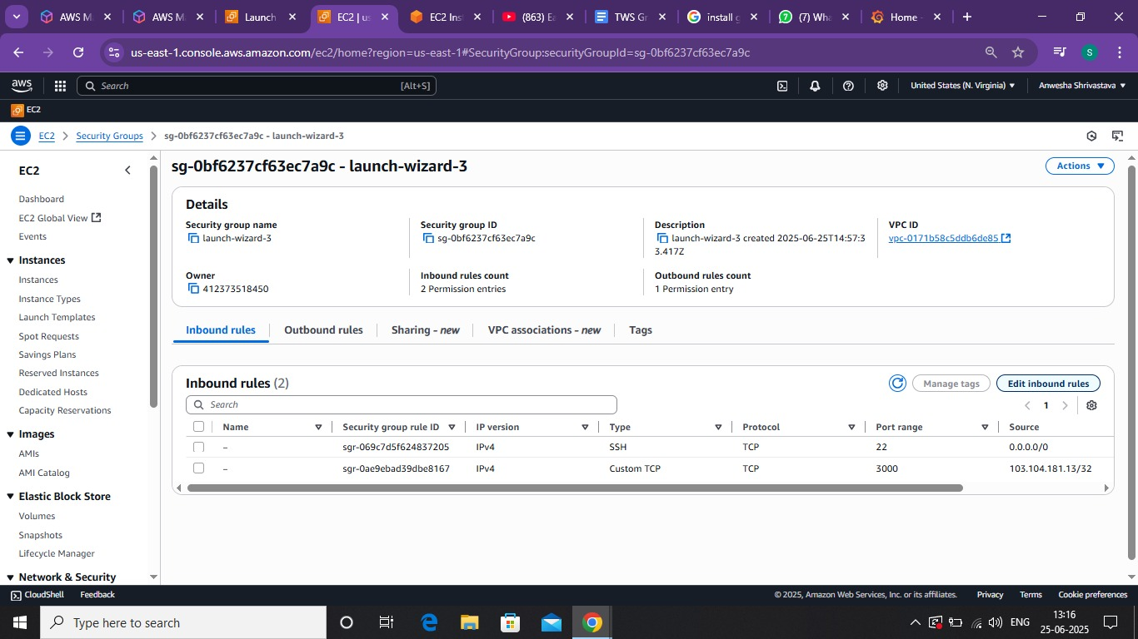

* Click on the Inbound rule and Create it.

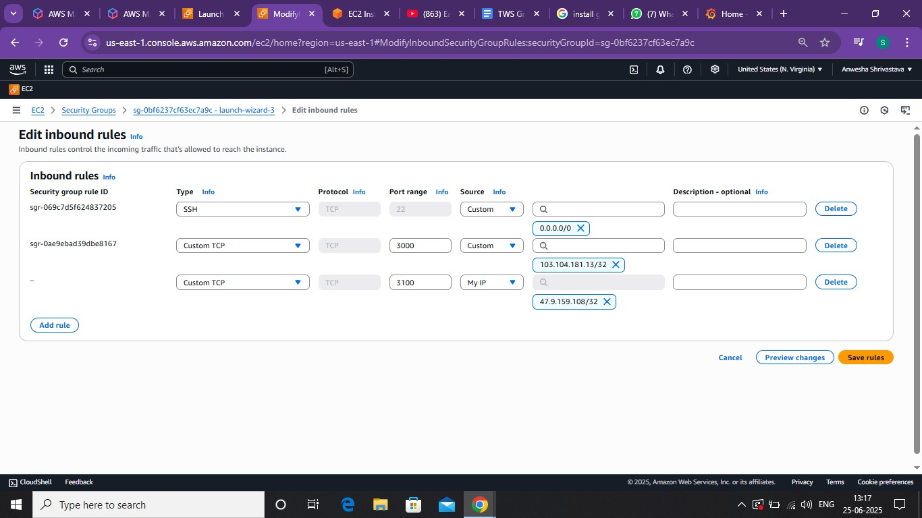

* Copy the instance public IP.

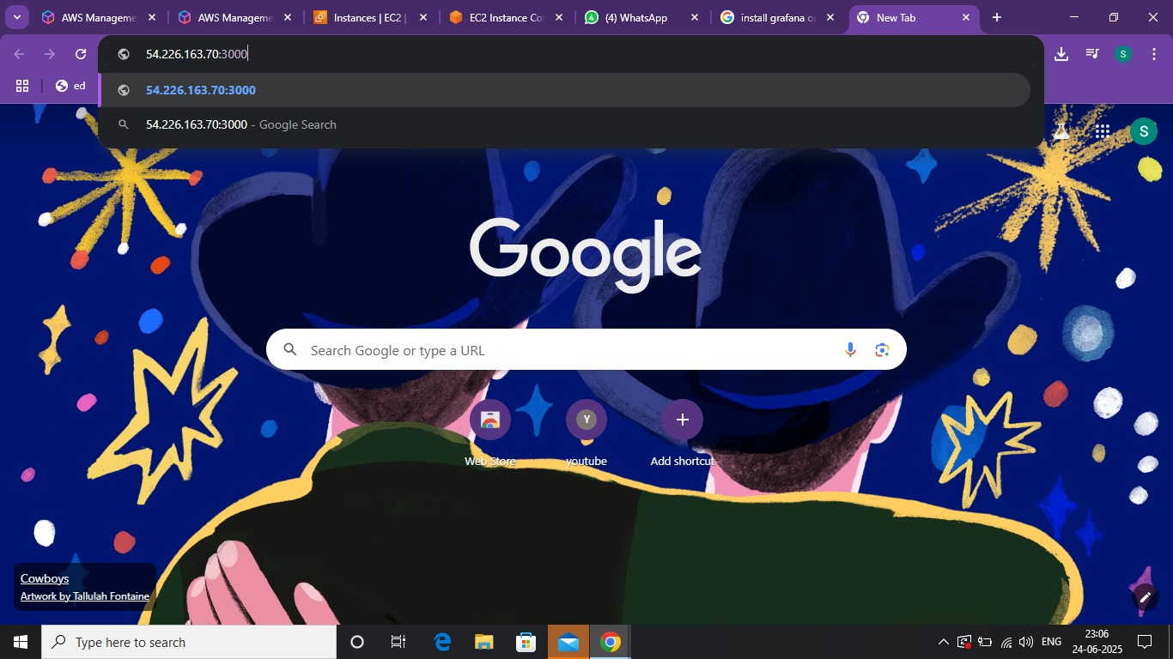

* You have now installed Grafana.

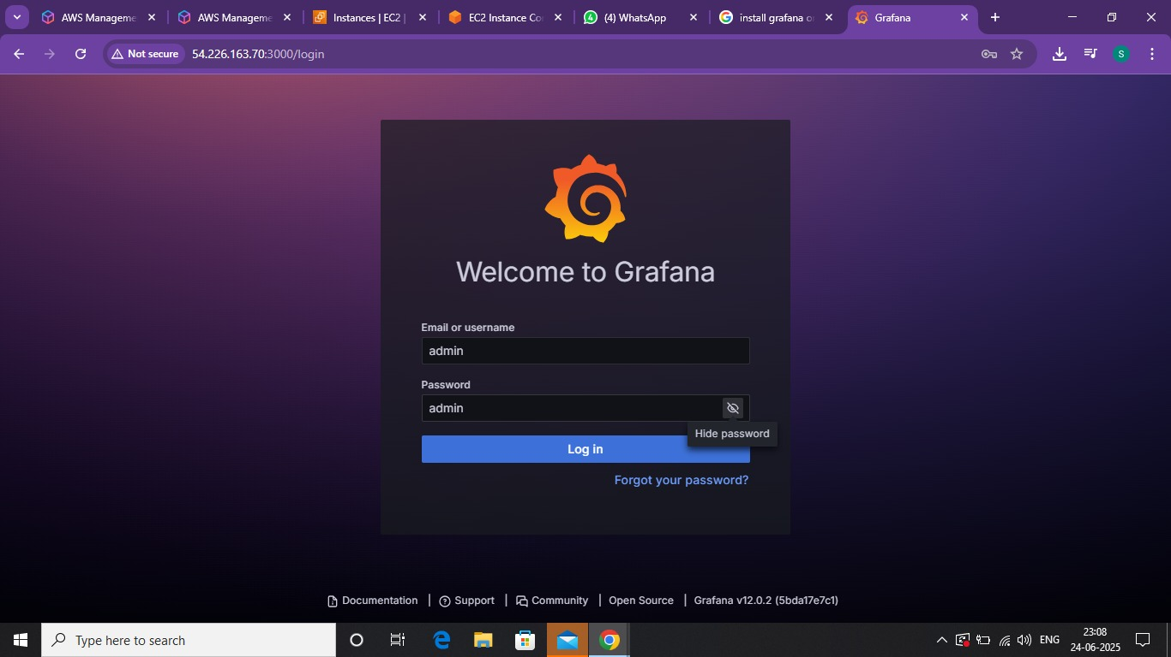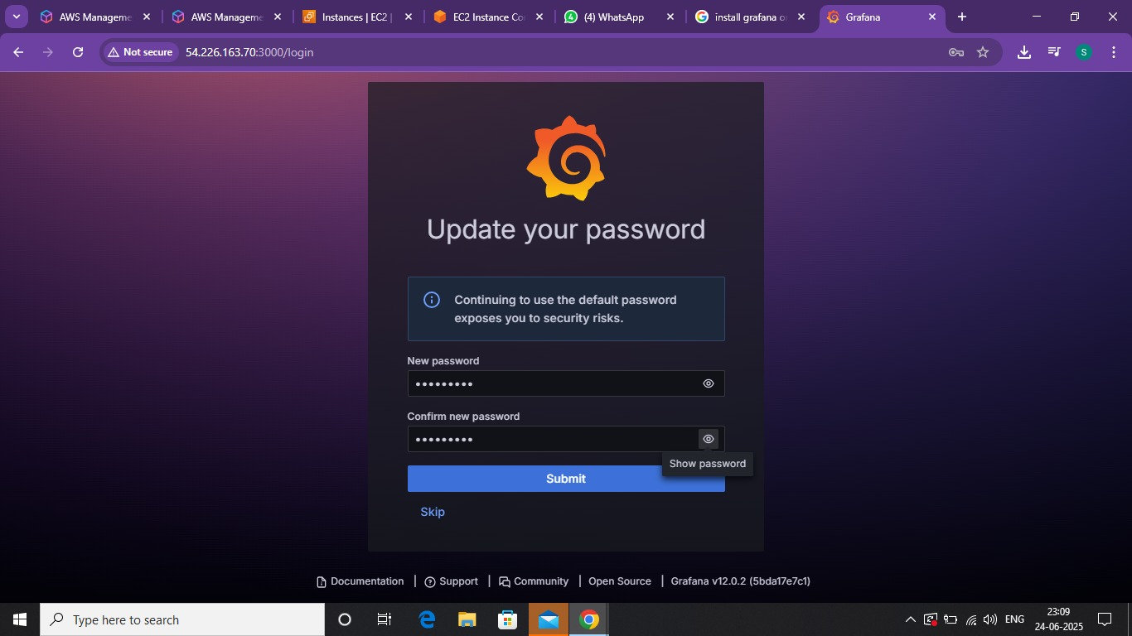

**6.Connecting Grafana with Loki**

To enable log visualization in Grafana, we need to configure **Loki** as a data source. Once connected, Grafana can query logs stored in Loki using **LogQL** and display them in panels and dashboards.

**Commands to install Loki:**

* **Sudo apt-get install docker.io.**
* **Docker.ps.**
* **Sudo usermod -aG docker $USER**
* **Sudo reboot**
* **Docker.ps.**
* **mkdir grafana_configs**
* **Cd grafana_configs/**
* **Ls**
* wget https://raw.githubusercontent.com/grafana/loki/v2.8.0/cmd/loki/loki-local-config.yaml -O loki-config.yaml
* **Ls**
* wget <https://raw.githubusercontent.com/grafana/loki/v2.8.0/clients/cmd/promtail/promtail-docker-config.yaml> -O promtail-config.yaml
* ls
* **vim loki-config.yaml**
* docker run -d --name loki -v $(pwd):/mnt/config -p 3100:3100 Grafana/loki:2.8.0 --config.file=/mnt/config/loki-config.yaml
* **Docker.ps**

**7.Again, create a security group for Loki:**



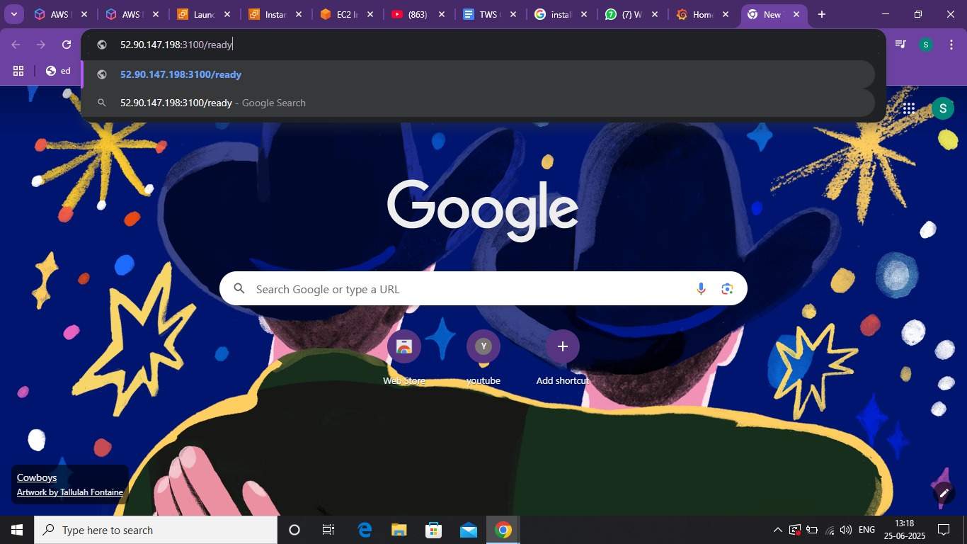

* docker run -d --name promtail -v $(pwd):/mnt/config -v /var/log:/var/log --link loki grafana/promtail:2.8.0 --config.file=/mnt/config/promtail-config.yaml
* **Docker.ps**

**7.** **Testing and Validation**

Once the Grafana, Loki, and Promtail stack is configured, it's important to test the setup to ensure that logs are being collected, stored, and visualized properly. This phase validates the functionality and reliability of the log monitoring system.

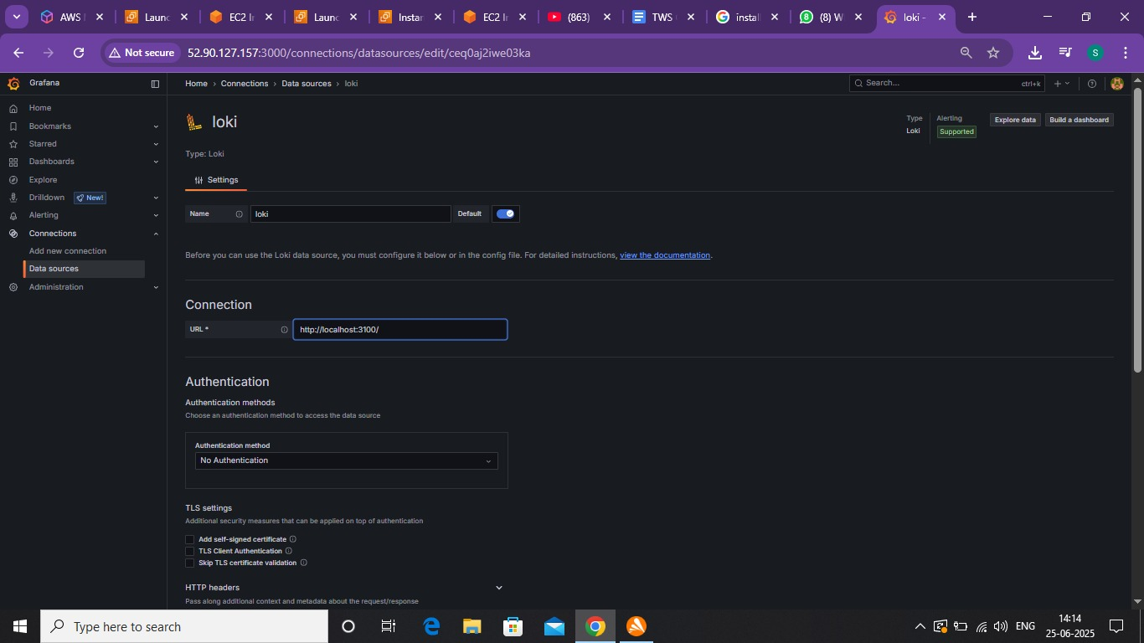.

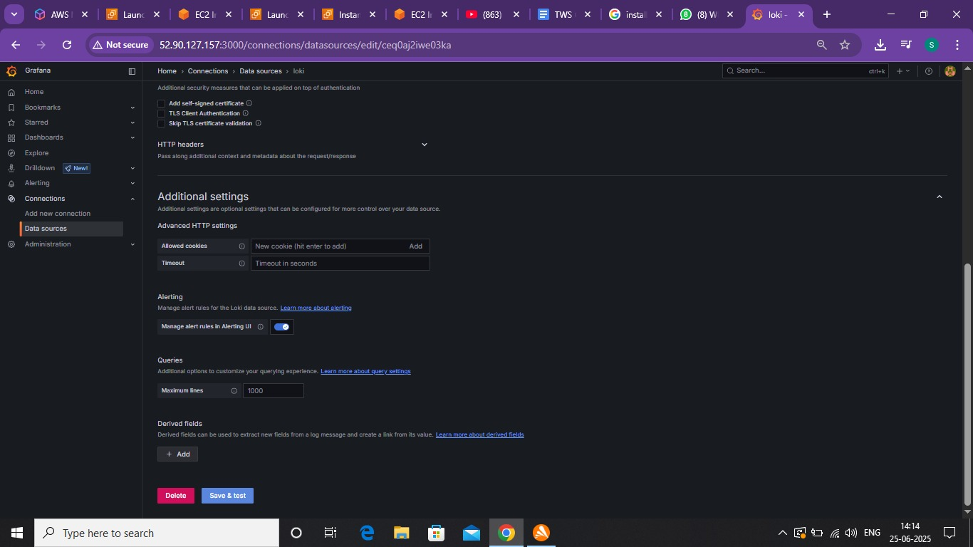

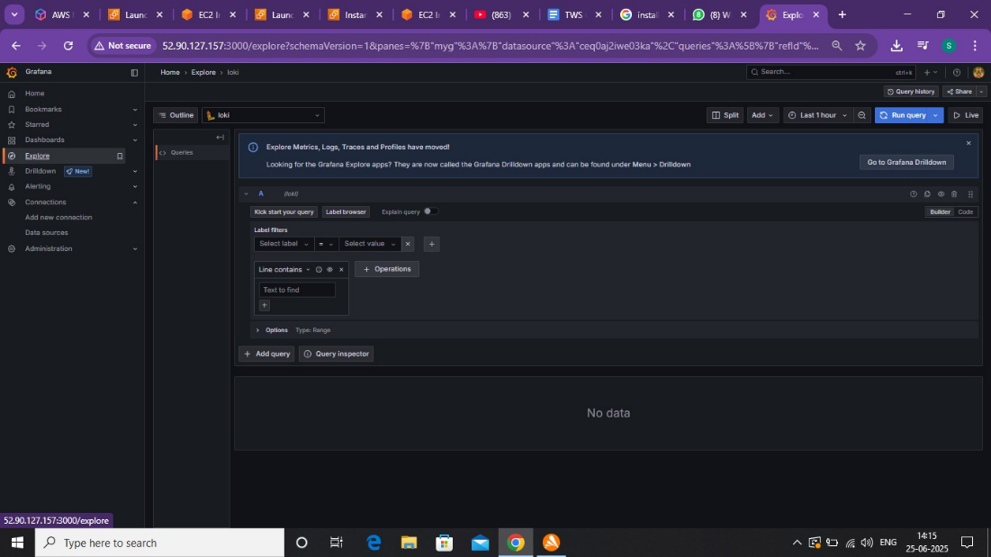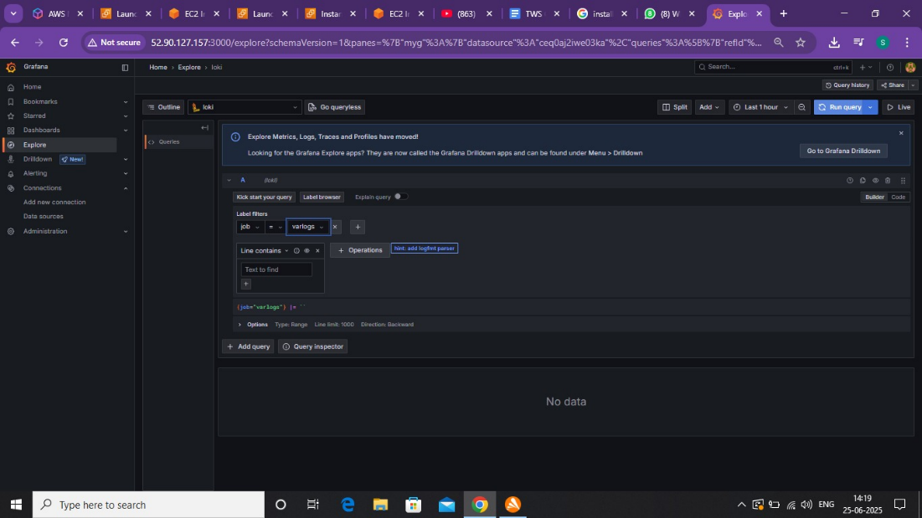

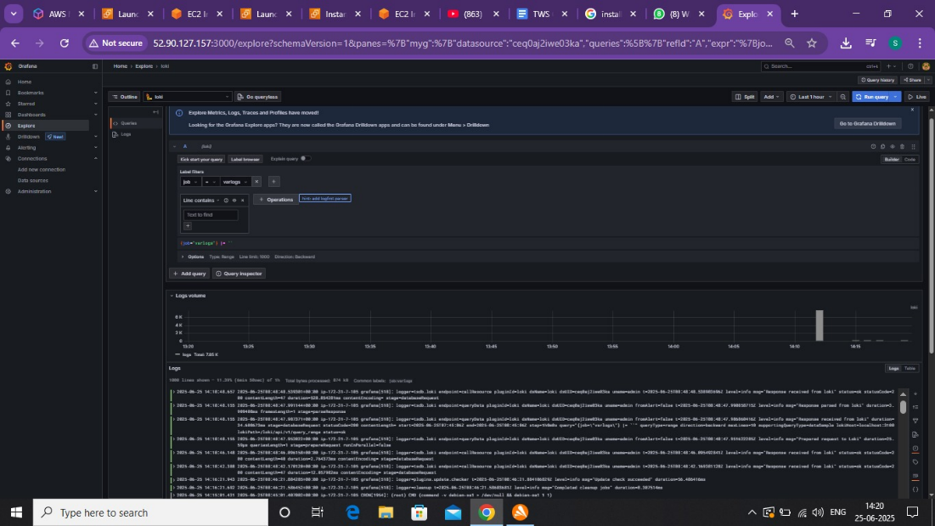

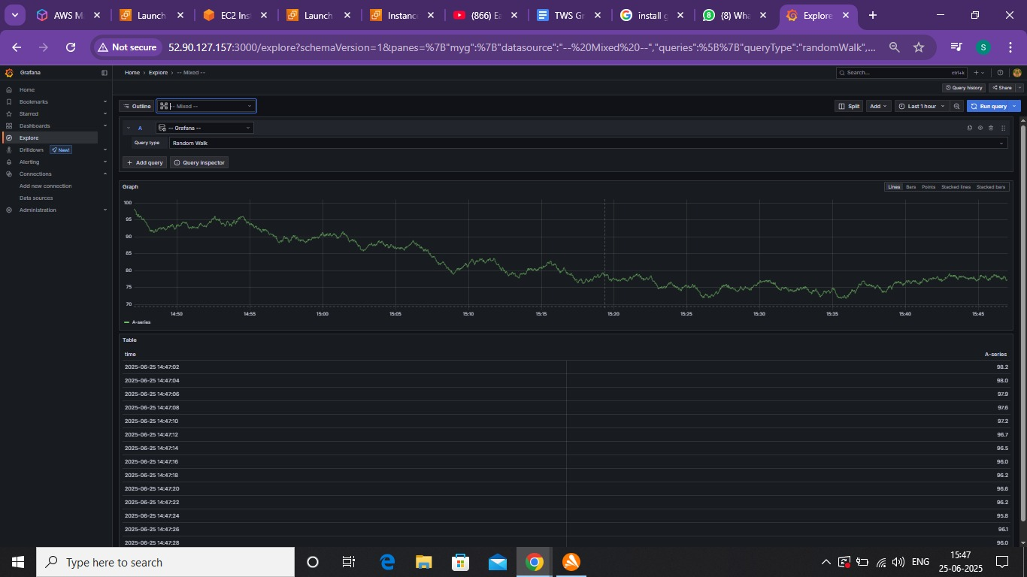

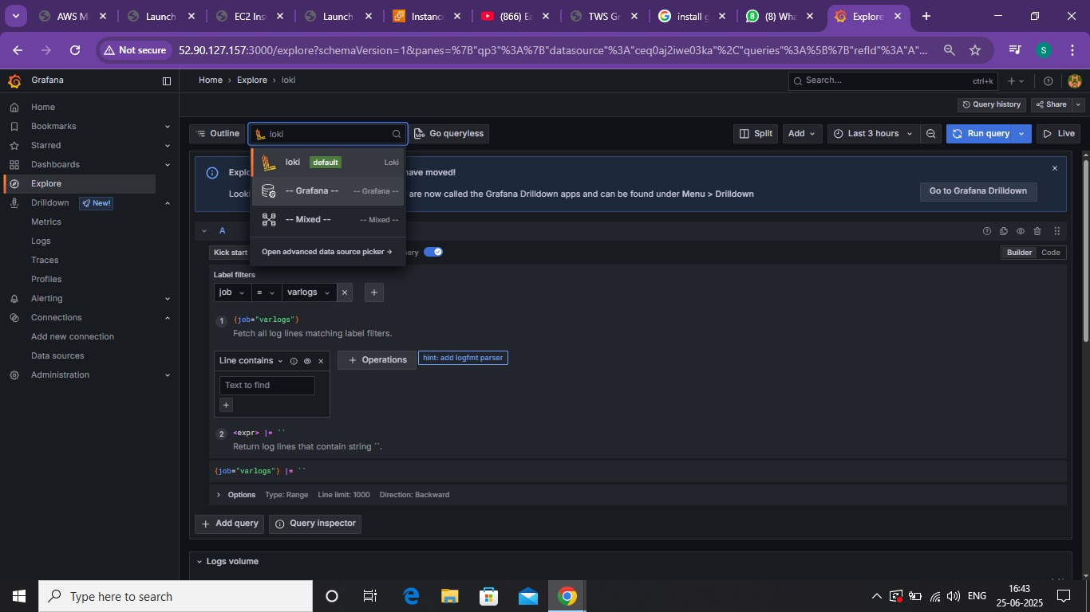

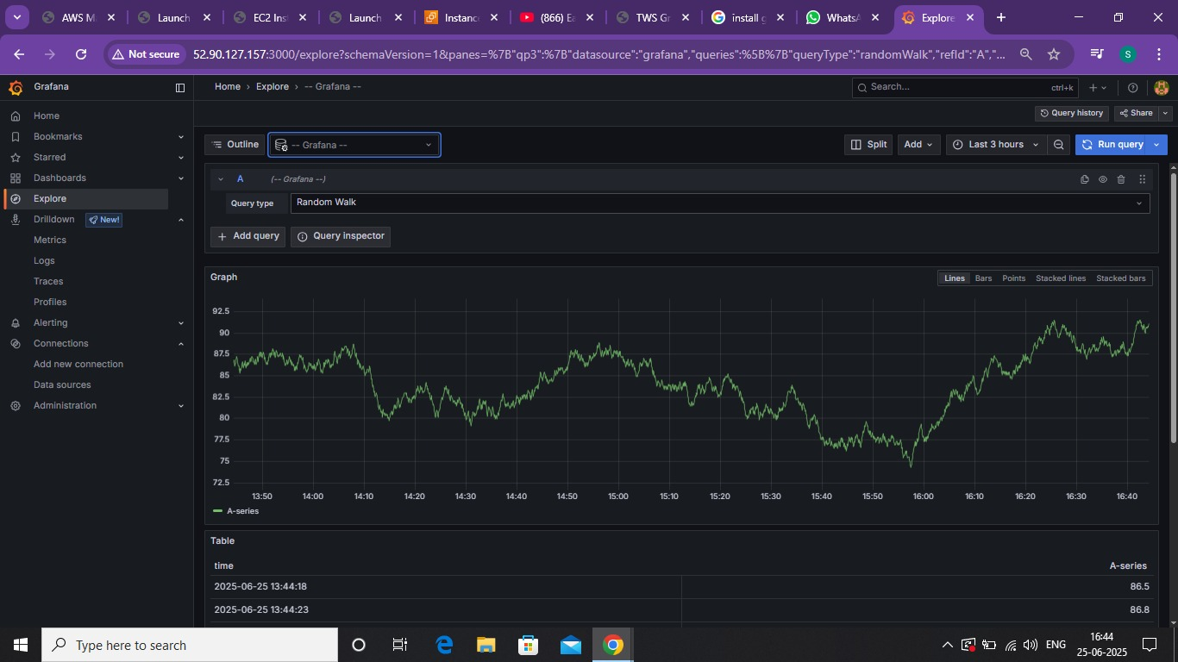

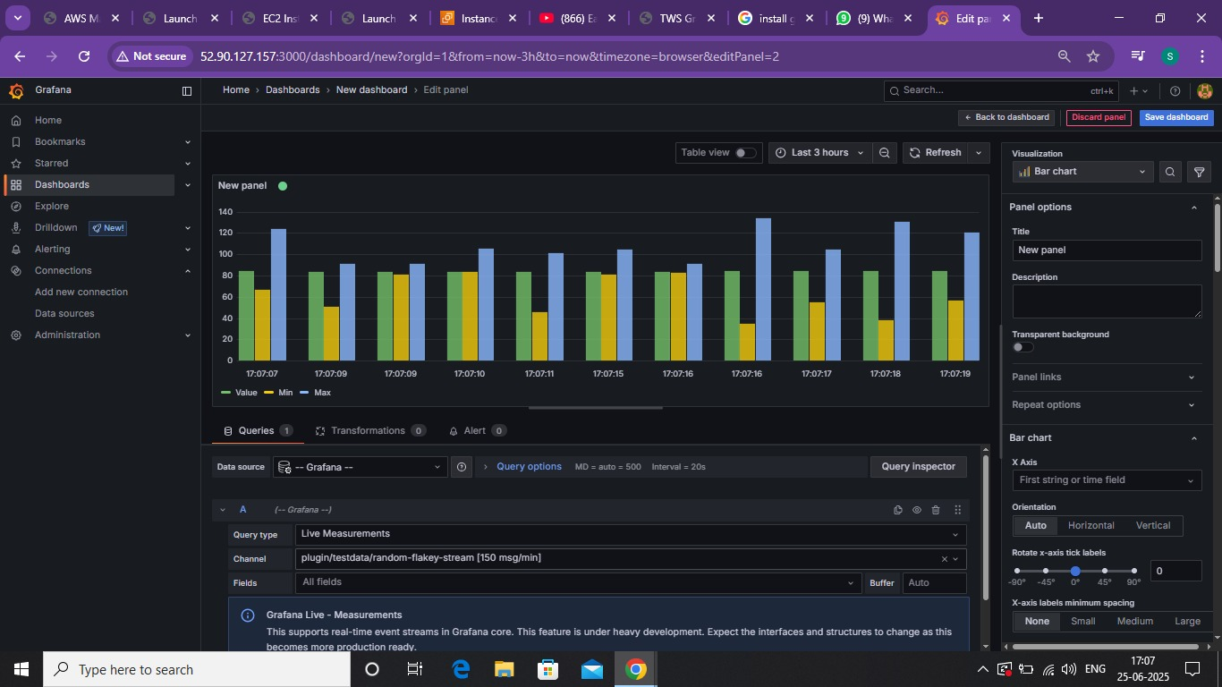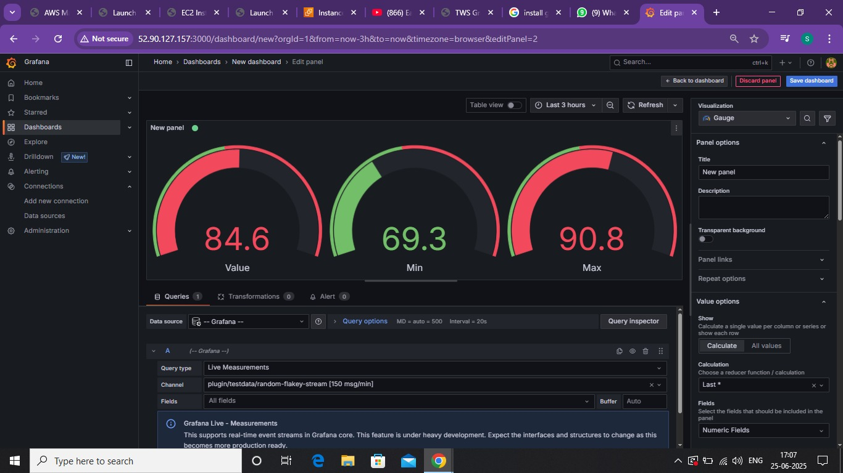

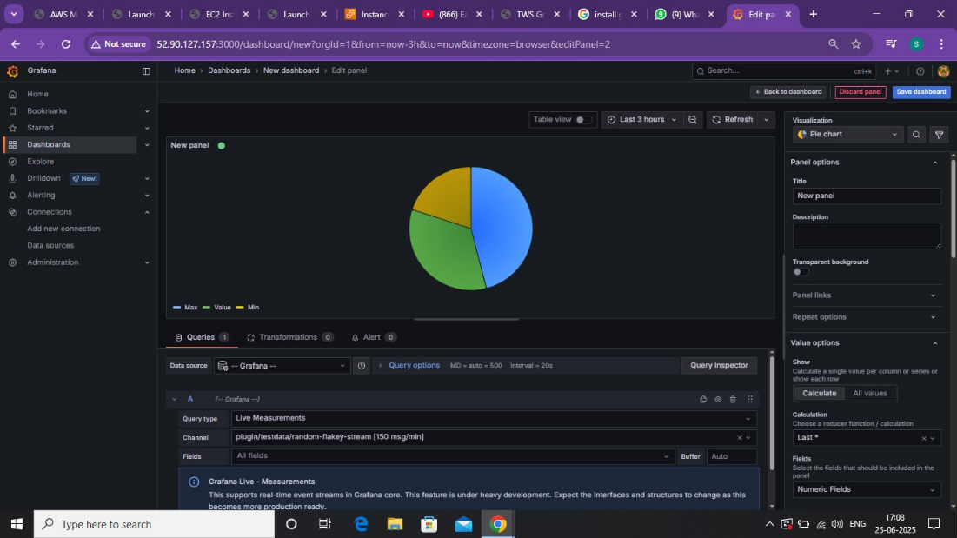

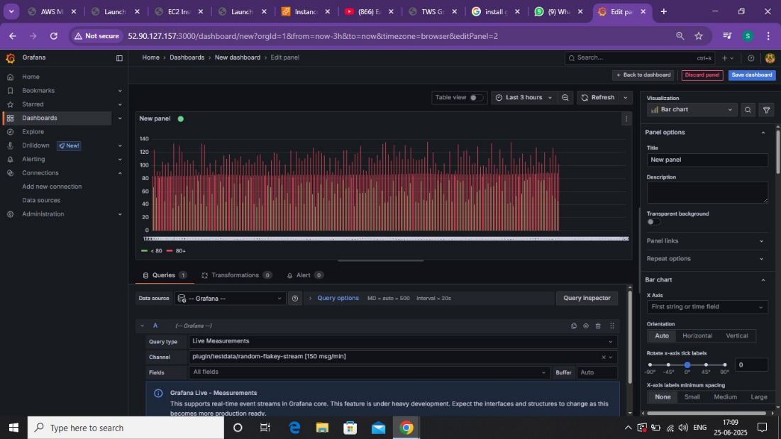

**8.Results and Observations:**

After successfully setting up the **Grafana + Loki + Promtail** stack on a Linux server, several tests and validations were performed to ensure the system's reliability, real-time performance, and usability. Below are the key results and observations from the project:

### **✅ Results**

* **Logs from the Linux system** (e.g., /var/log/syslog, /var/log/auth.log, custom logs) were successfully collected using **Promtail**.
* Logs were **pushed to Loki** without delay and stored with appropriate labels for efficient querying.
* **Grafana dashboards** were created to display:
  + Raw logs
  + Filtered logs using keywords
  + Graphs showing log count trends over time (using LogQL)
* Real-time updates were visible in the Grafana panels when new logs were generated.
* The **LogQL queries** allowed precise filtering, making it easy to isolate errors, warnings, and custom patterns in the logs.

### **🔍 Observations**

* The system is **lightweight** and efficient, with minimal resource usage on the server.
* **Promtail’s configuration** (especially paths and labels) must be precise—misconfiguration can cause missing logs.
* Logs can be filtered effectively using LogQL, but the syntax requires a learning curve.
* **Grafana’s Explore feature** was particularly useful for ad hoc querying and troubleshooting.
* **Dashboard customization** (with multiple panels and time series) allows flexibility in visualizing different types of logs (e.g., errors, login attempts, service failures).
* Alerts can be set up in Grafana (optional), though not configured in this phase.

**9.** **Conclusion:**

Grafana, combined with Loki and Promtail, provides a robust and efficient solution for centralized logging and observability. **Loki** offers a highly scalable log aggregation system that is optimized for storing and querying logs in a cost-effective way, especially when paired with **Promtail**, which efficiently collects and ships logs from various sources to Loki. Unlike traditional log management systems, Loki’s label-based indexing approach integrates seamlessly with Grafana, enabling users to correlate logs with metrics and traces in a single, unified interface. This powerful trio simplifies troubleshooting, improves system visibility, and enhances operational efficiency for both development and DevOps teams. Together, they form a modern, lightweight, and scalable observability stack tailored to meet the evolving needs of cloud-native environments.